Jake Traut

CSCI 4446 Problem Set 12

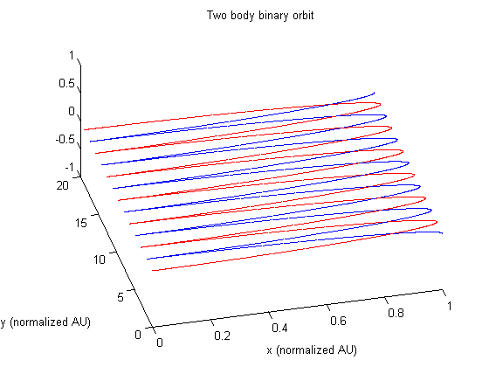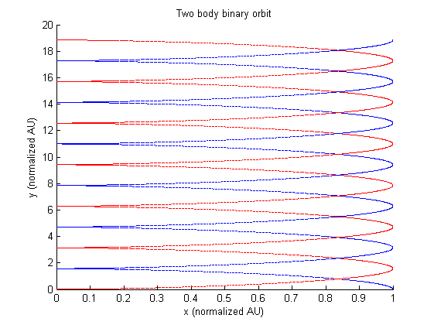Binary star system – integrating the two-body equations

Integrating the two-body equations with RK4 produced a binary orbit that maintains its shape. In other words the masses will stay in this orbit infinitely with the assumption that inertia is never lost. This was expected with our simplified models. It should also be noted that the center of mass of the system moves along the positive y axis, in relation to the initial velocity used for the 2nd mass (blue, away from origin) [0 1 0], which starts in the y direction.